Assiut University

Faculty of Computers & Information

Department of …

**Graduation Project**

**Academic Year 2022-2023**

Smart Classroom

Project Report

Smart Classroom

Project Report

Project Team

Mostafa Usama Ahmed – 162019153

Mohamed Nabil Hassan – 162019141

Mohamed Ramadan Farouk – 162019129

Nourhan Mahmoud Hassan– 162019172

Manar Mohamed Sayed– 162019161

Sondos Osama Mohamed – 162019071

Supervisor

Prof. Abdel-Rahman Hedar

**2023**

Table of Contents

1. Project Proposal
   1. Abstract …………………………………………………………………………………………………………..…………………...… 3
   2. Objectives ……………………………………………………………………………………………………………………………….. 3
   3. Approaches and Methodology ………………………………………………………………….…………………………….. 4
   4. Plan and Management ………………………………………………………………………………………………….………… 4
2. System Analysis
   1. Introduction ……………………………………………………………………………………………………………………………… 6
   2. Overall Description …………………………………………………………………………………………………………………… 7
   3. External Interface Requirements ………………………………………………………………………………………………. 8
   4. System Features ……………………………………………………………………………………………………………………….. 9
   5. Other Non-Functional Requirements ………………………………………………………………………………………… 9
   6. Other Requirements ……………………………………………………………………………………………………………….. 10
3. Software Design
   1. Introduction …………………………………………………………………………………………………………………..…..….. 11
   2. System Overview ………………………………………………………………………………………………………………..….. 12
   3. System Architecture ……………………………………………………………………………………………………………….. 12
   4. Data Design …………………………………………………………………………………………………………………….……… 15
   5. Component Design ……………………………………………………………………………………………………………….… 16
   6. Requirements Matrix ……………………………………………………………………………………………………………… 17
4. Implementation …………………………………………………………………………………………………………………………….. 18
5. Future Works and Conclusion ………………………………………………………………………………………………………… 20

**Project Proposal**

# Project Abstract

Universities use a dramatically large amount of energy, and quite a lot of this is unnecessarily wasted. This means that education facilities are spending a lot of their allocated budget on energy, despite potentially not using all that they are paying for, and as budgets are becoming more and more limited, saving energy through minimizing running costs and power wastage in universities, is a method that can come in very useful.

Electricity saving can be achieved through the efficient use of energy, such as turning off lights, fans, air conditioning, and other electrical appliance when not in use. This project aims to prevent wasting Electricity in the classroom by implementing a tiny machine learning system that will detect and count the number of students entering and exiting the classroom using a sensor system and cameras, and Based on this information, the system will decide whether to turn on the electrical devices or not

The system will reduce the consumed energy, cost, and human resources by automating the process of lighting and ventilation.

# Project Objectives

Reduce the energy consumed in classrooms by automating the process of lighting and ventilation. This system will save up to 20% more power. It will also reduce the cost and human resources wasted. Since universities use a dramatically large amount of energy, this system will improve the current systems and save more resources. The system will be running by July 2023. To achieve such goals, we propose the following objectives:

1. Design data collection models for the sensor resources.
2. Design machine learning models to detect humans and their position.
3. Develop smart systems for classroom power control.

# Approaches and Methodology

* Use sensors to detect any motion in the classroom.
* Gathering data with cameras
* Use a microcontroller/microprocessor to control the electrical devices.
* Pre-processing the collected data to remove any noise.
* Applying machine learning algorithms to detect humans and their position.
* Adjust the power consumption based on the position of the humans.

# Project Plan and Management

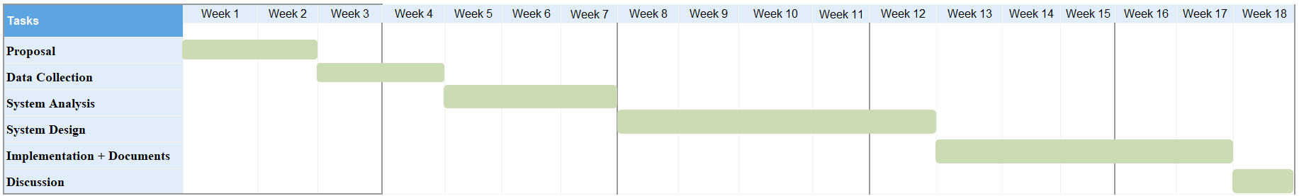**First Semester**

Figure 1. First semester timeline.

**First semester tasks**

|  |  |
| --- | --- |
| Task | Team Members |
| Project Proposal | **All team members** |
| Data Collection | **Nourhan Mahmoud,**  **Manar Mohamed** |
| System Analysis | **Mostafa Usama,**  **Mohamed Nabil** |
| System Design | **Sondos Osama,**  **Manar Mohamed,**  **Nourhan Mahmoud** |
| Implementation + Documents | **Mostafa Usama,**  **Mohamed Nabil,**  **Mohamed Ramadan** |
| Discussion | **All team members** |

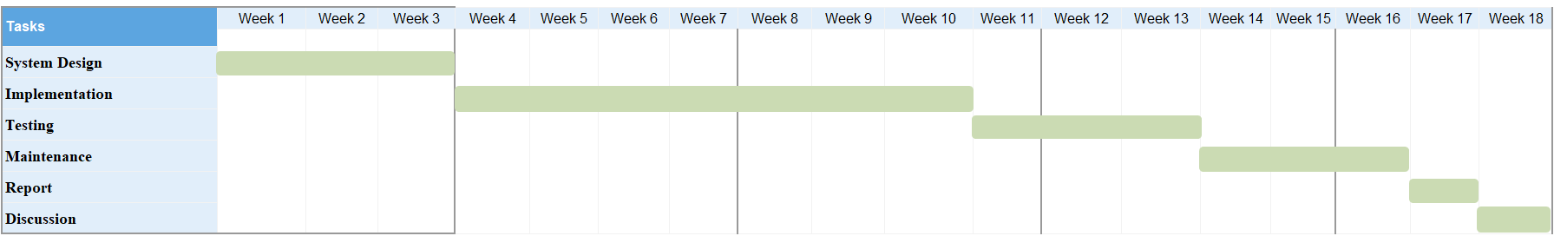**Second Semester**

Figure 2. Second semester timeline.

**Second semester tasks**

|  |  |
| --- | --- |
| Task | Team Members |
| System Design | **Sondos Osama,**  **Manar Mohamed,**  **Nourhan Mahmoud** |
| Implementation | **Mostafa Usama,**  **Mohamed Nabil,**  **Mohamed Ramadan** |
| Testing | **Nourhan Mahmoud,**  **Sondos Osama** |
| Maintenance | **All team members** |
| Report | **All team members** |
| Discussion | **All team members** |

**System Analysis**

# Introduction

The following sections provides an overview the software requirements specifications for the smart classroom.

## Purpose

The purpose of this SRS is to determine both functional and non-functional requirements of the system in the classroom which will control the lighting and ventilation .Also the document provides an overall description with UML analysis models.

## Document Conventions

The document is prepared using Microsoft Word 2013 and has used the font type 'Times New Roman'.  
The fixed font size that has been used to type this document is 14pt with 1.5 line spacing. It has used the bold property to set the headings of the document.

## Intended Audience and Reading Suggestions

Intended reader groups for this software requirement specification are the Faculty Administration, the lecturer, the project team, and the supervisor

Through this document, the workload needed for development, validation and verification will ease. To be specific, this document is going to describe functionality, external interfaces, performance, attributes and the design constraints of the system which is going to be developed.

## Product Scope

This project aims to prevent wasting electricity in the classroom by implementing a tiny machine learning system that will detect and count the number of students entering and exiting the classroom. Also the system will reduce the consumed energy, cost, and human resources by automating the process of lighting and ventilation.

# Overall Description

## Product Perspective

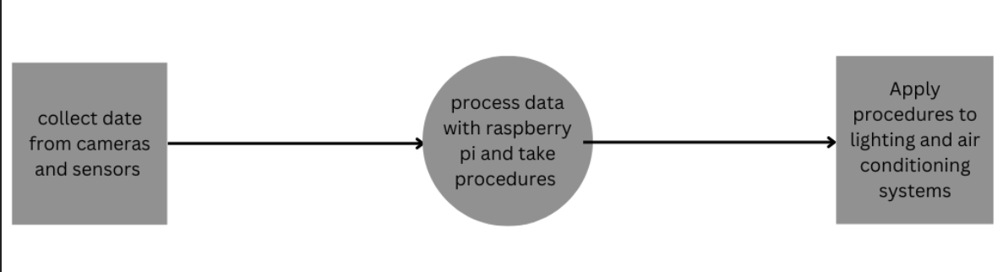 The smart classroom system is a new self-contained product which will be produced by the project team in order to overcome the problem of wasting energy, this classroom system manages the electrical devices in the classroom by collecting data from sensors and cameras, then processing this data, taking action, and finally sending orders to the lighting system, air conditioning, and more, the final outcome of this project will increase the efficiency of the current systems and will reduce energy wasted.

Figure 3. Major system components.

## Product Functions

The system will help make the classroom more energy efficient with some functions such as:

1. Calculate the total number of people in the classroom.
2. Count the number of people in a specific section of the classroom
3. Control the lighting in a specific space based on the number of people in that space and turn it off when not in use.
4. Control air conditioners in a specific place based on the temperature and the number of people present in that place, and shut them down when not in use.

## Operating Environment

**Hardware:**

1. Heat sensors
2. Camera
3. Raspberry Pi microprocessor

**Software:**

1. Microsoft SQL Server Management Studio Express 2010.
2. Raspbian Operating system.

## Design and Implementation Constraints

1. All electrical connections must be in place and all appliances working efficiently.
2. The system will be suitable for regular classrooms and not for huge halls or open spaces

## User Documentation

There will be a simple user manual written in an understandable way to operate the system, and there will be a hard copy that will be delivered with the system.

## Assumptions and Dependencies

Assuming that there is a machine vision model for counting people in the classroom, this algorithm can be used in the system after modification, or this model will be generated from scratch.

# External Interface Requirements

## Hardware Interfaces

* A camera will be used to take photos of the students in the classroom to determine their position, the camera should be placed in an appropriate location to take pictures of the classroom with a good angle.
* Various sensors will also be used to determine the temperature of the classroom, these sensors will be placed all around the classroom to accurately calculate the temperature.
* The GPIO pins in the raspberry PI will be used to connect the electrical devices with the microprocessor and control them based on collected information from the camera and the sensors.

## Software Interfaces

The Python programming language version 3.10 will be used to develop the software, Google Colab platform will be used for developing the system, OpenCV or Tensorflow libraries will be used for detecting students in the classroom, Proteus software will be used to simulate how the system will work.

# System Features

## Feature 1: Control Lighting

* **Description and Priority:**

Control the lighting in the classroom (High Priority).

* **Stimulus**

A student sits on a place with no lights on.

* **Response Sequence**

The lights are turned on on this position.

## Feature 2: Control Ventilation

* **Description and Priority**

Control the ventilation in the classroom (High Priority).

* **Stimulus**

The temperature in the classroom is high.

* **Response Sequence**

The fans/air conditioning are turned on.

## Feature 3: Counting Students

* **Description and Priority**

Counting the number of students (High Priority).

* **Stimulus**

A student enters or leaves the classroom.

* **Response Sequence**

The number of the students will change.

# Other Non-functional Requirements

## Performance Requirements

* The accuracy of the detection model should not be less than 95%.
* The response of the system should not exceed 3 seconds,
* The system would not slow down under high workloads.

## Safety Requirements

* In case of failure, the system will switch to safe mood and the user will be able to control the electrical devices manually

## Security Requirements

* Only developers can make modifications to the RPI

## Software Quality Attributes

* **Availability**: the system will be working during all working hours of the university.
* **Maintainability**: maintain sessions would not take more than 2 hours
* **Environmental**: RPI will be protected by a cooling system to prevent any damage caused by the weather

# Other Requirements

Appendix A: Glossary

|  |  |
| --- | --- |
| RPI | raspberry PI |
| ML | Machine Learning |
| GPIO | General purpose input output |
| UML | Unified Modeling Language |
|  |  |

Appendix B: Analysis Models

Figure 4.

**Software Design**

# INTRODUCTION

## Purpose

*This software design document describes the architecture and system design of the smart classroom. It also contains the high­ level requirements for the project. The technical specifications for this project have been drafted following several meetings between the development team and the supervisor of the project. This project will implement a smart classroom system to control electrical devices.*

## Scope

This project aims to prevent wasting electricity in the classroom by implementing a tiny machine learning system that will detect and count the number of students entering and exiting the classroom. Also, the system will reduce the consumed energy, cost, and human resources by automating the process of lighting and ventilation.

## Overview

*Universities use a dramatically large amount of energy, and quite a lot of this is  
unnecessarily wasted. This means that education facilities are spending a lot of their allocated budget on energy, despite potentially not using all that they are paying for, and as budgets are becoming more and more limited, saving energy through minimizing running costs and power wastage in universities, is a method that can come in very useful. Electricity saving can be achieved through the efficient use of energy, such as turning off lights, fans, air conditioning, and other electrical appliance when not in use. This project aims to prevent wasting Electricity in the classroom. The system will reduce the consumed energy, cost, and human resources by automating the process of lighting and ventilation.*

# SYSTEM OVERVIEW

The system will control the electrical devices by dividing the classroom into a group of sections, then count the number of students on each section using a detection algorithm called DSFD, and with this information, the system will decide whether to turn on the electrical devices or not.

* **Algorithm Description**

DSFD architecture is a Face Detection Algorithm mainly based on the SSD (Single Shoot Multi Box Detector) key different feature maps at various depth that are transformed in six “enhanced” feature maps by a module called (Feature Enhance Module).

The algorithm has three stages:

-**Feature Extraction:** Which contains a stack of convolutional networks that generate feature maps and encode the useful information about the image.

-**Detection Head:** It is also a stack of convolutional networks to generates box predictions and class confidence.

**-Non-Maximal Suppression (NMS):** Used to remove the repeated detections in order to get better performance.

* **Pseudocode**

1. Initialize the camera, sensors and Raspberry PI.
2. Take a frame (image) from main camera.
3. Check the temperature from the heat sensor
4. Send input images to DSFD detection () to construct the number of student faces in classroom.
5. Count Function () takes the constructed images and count the number of student faces in each section.
6. Control Electrical device function () lights a specific section based on the number of students in that section or turn it off when not in use.
7. Return full control of electrical devices.

# SYSTEM ARCHITECTURE

## Architectural Design

* The camera will take pictures of the classroom and the sensors will measure the temperature and send this information through the GPIO pins to the Raspberry PI.
* The Raspberry PI will receive this information and count students number in each section and then sends a signal to the electrical devices in the classroom through the GPIO pins.
* the electrical devices will be turned off or on based on the sent signal.

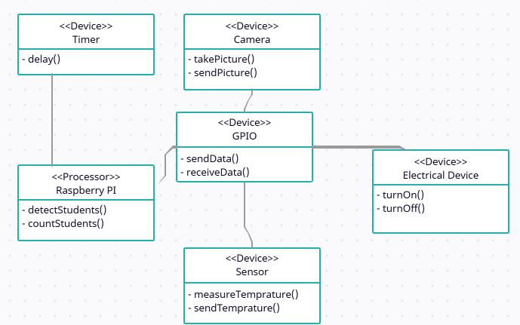

Figure 5. Deployment diagram.

## Decomposition Description

System functions:

* Capture pictures.
* Read temperature.
* Calculate student count.
* Calculate student location.
* Determine in which section is the student.
* Check count, location and temperature
* Turn on/off Electrical devices

Structural decomposition diagram:

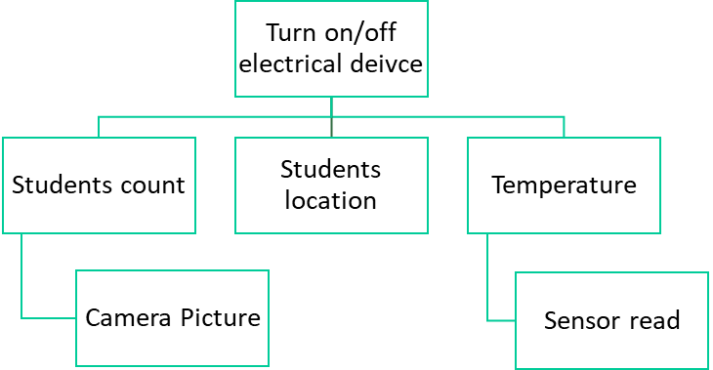

Figure 6. This diagram shows the functionality of the system as a whole and the steps needed to reach this functionality.

Dataflow Diagram:

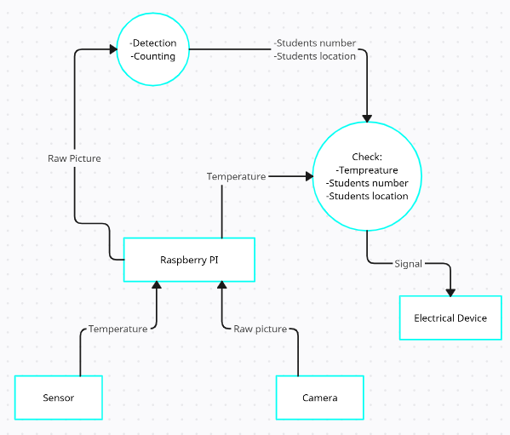

Figure. 5 This diagram shows the workflow of the system and how all the individual components communicate with each other to achieve the whole systems’ functionality.

## Design Rationale

This architecture has several valuable applications. You can use it to show which software elements are deployed by which hardware elements, illustrate the runtime processing for hardware and provide a view of the hardware system’s topology. Which fits our overall system that contains both hardware and software.

# DATA DESIGN

## Data Description

The camera sends picture data and the sensors send temperature data to the Raspberry PI and then it stores this information for processing. The Raspberry PI checks the temperature and apply the DSFD detection algorithm to detect the students and count them, and finally, the Raspberry PI sends a voltage signal to the electrical devices.

## Data Dictionary

|  |  |  |
| --- | --- | --- |
| Data | Type | Description |
| Classroom picture | Image | A picture captured by the camera |
| Temperature | Electrical signal and later converted to digital signal | The current temperature of the classroom read by the sensors |
| Raspberry PI signal | Electrical signal | A signal that decides if the electrical device is turned on or off |

|  |  |  |
| --- | --- | --- |
| Function | Parameter | Data returned |
| Capture picture | None | Classroom picture (Image) |
| Sensor read | None | Temperature (Electrical signal) |
| Calculate students count | Classroom picture | Number of students in each section (List of integers) |
| Calculate students location | Classroom picture | Location of students (Coordinates) |
| Determine the section | Location of students | The section (Section index) |
| Check data | Students count, and temperature | Flag (Bool) |
| Turn on/off electrical device | Electrical signal from the Raspberry PI | None |

# COMPONENT DESIGN

**- Sensors :** Measures the temperature of its environment and converts the input data into electronic data to record then send this data to Raspberry PI

**- Cameras :** Iteratively collect images and send these images to Raspberry PI

**- Raspberry PI:** The photos taken from the cameras and temperature read from sensors are analyzed and passed through the system to count the number of students, find out their locations, perform some operations, then decide whether to turn on the devices or not and send the command taken to the electrical devices.

**- Electrical Devices :** Through commands sent to the devices, the devices are turned on or off

# REQUIREMENTS MATRIX

|  |  |  |  |  |
| --- | --- | --- | --- | --- |
| Req. Number | Req. Name | Req. Description | Req. Place | Design |
| 1 | Count people | Count total number of people in specific area in the classroom. | 2.2 Product Functions | Not Started |
| 2 | Control the lighting in a specific area. | Turn on the light based on the number of people in that area, and turn off when it’s not in use. | 2.2 Product Functions | Not Started |
| 3 | Control fans and air conditioners in a specific area. | Turn on air conditioners based on the temperature and number of people in that area, and turn off when they are not in use. | 2.2 Product Functions | Not Started |